Press

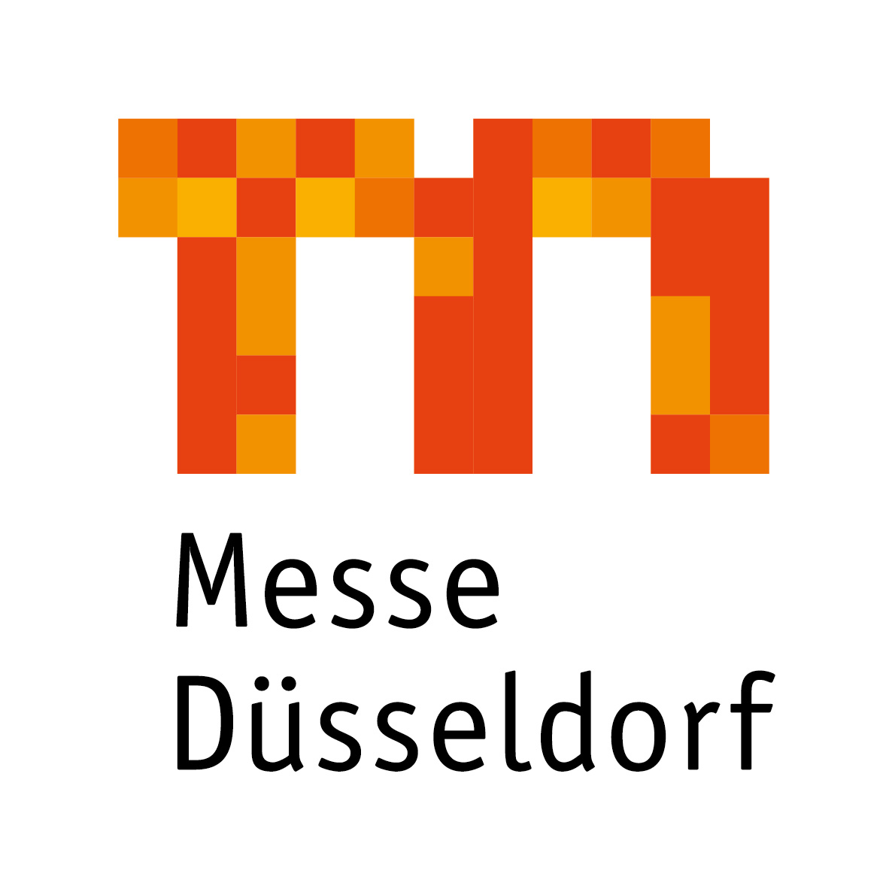
Forward-looking course charted in the operative
management of Messe Düsseldorf GmbH:
Wolfram Diener succeeds Joachim Schäfer

The supervisory board of Messe Düsseldorf GmbH headed by its chairman Lord Mayor Thomas Geisel appointed Wolfram Diener (54) the new operative managing director in its meeting on 15 May 2018. He succeeds Joachim Schäfer (64) in this position, who will retire from the company in late August 2018 reaching his agreed retirement age. Diener will take on his new duty with Messe Düsseldorf on 1 October 2018.

Wolfram Diener will take over the divisions that Joachim Schäfer has been responsible for since 2006: the Global Portfolios Health and Medical Technologies (MEDICA, COMPAMED, REHACARE International) and Metals and Flow Technologies (GIFA, THERMPROCESS, NEWCAST, Pump Summit, Valve World Expo, METEC, wire, Tube), the leading trade fair trio BEAUTY DÜSSELDORF, TOP HAIR – DIE MESSE with the make-up artist design show, A+A – Safety, Health and Security at Work, glasstec as well as the trade fair duo CARAVAN SALON DÜSSELDORF/TourNatur. Furthermore, he will be in charge of the business division “Digital Strategy and Communication” newly established in 2017 encompassing the IT and Inhouse Services, Marketing Services, Advertising and Trade Press departments.

“We are pleased to see that the supervisory board followed our personnel proposal and appointed Wolfram Diener. Our aim is to ensure a consistent transfer of business for our customers thereby guaranteeing continuity,” said Werner M. Dornscheidt, President & CEO of Messe Düsseldorf GmbH. He added that he had known Diener for many years and was convinced of his excellent expertise in the trade fair business that he had acquired through broad-based industry and leadership experience as well as outstanding activities and high profitability in an international market-leading group – especially in the Asian region. This created the ideal prerequisites, he went on, to successfully develop Messe Düsseldorf’s product portfolio further and to continue along the way of digital transformation.
A graduate in business management, Wolfram Diener started his professional career in 1991 as the division head for catering and events at the Baden-Württemberg horticultural show in Pforzheim before he joined Hamburg Messe- und Congress GmbH as a Project Director for foreign trade fairs from 1992 to 1997. From 1997 he served Messe Frankfurt (H.K.) Ltd. as a managing director for Asian operations. 2001 saw Diener change to the management of Shanghai New International Expo Centre Ltd., one of the world’s biggest trade fair centres, a Chinese-German joint venture that Messe Düsseldorf holds a share in. From 2005 to 2011 he took over the operation of the convention and congress centre as well as exhibitions and special events and hotel logistics as Vice President at Venetian Macau Ltd. and Marina Bay Sands Singapore Ltd.. Since 2011 he has been successfully active as Senior Vice President at UBM Asia Ltd. in Hong Kong and responsible for the China business as well as selected global trade fair formats.

Thomas Geisel: “Supervisory board and shareholders agreed that Wolfram Diener is the optimal successor to Joachim Schäfer in both personal and professional terms and stands for a clear operative strategy, sustainable positioning of trade fairs and digital transformation.” They were confident, they said, that Diener would leverage his extensive know-how together with the top trade fair team to position the city’s subsidiary as an economically outstanding, digital company in the trade fair landscape in future.

Wolfram Diener is married with three children.

3,659 characters (with spaces)

The Messe Düsseldorf Group*:
With a turnover of around EUR 360m in 2017, the Messe Düsseldorf Group maintained its position as one of Germany's most successful trade fair companies. To the tune of 28,700 exhibitors presented their products to 1.35m trade visitors at events in Düsseldorf this year. They were joined by over half a million visitors to various conventions. About 50 trade fairs were held in Düsseldorf, including 23 No. 1 events in five areas of expertise: machinery, plants and equipment, retail, skilled crafts and services, medicine and healthcare, fashion and lifestyle, and also leisure. In addition, there were about 70 proprietary, joint and contracted events outside Germany, demonstrating that the Messe Düsseldorf Group is a leading global platform for export. Messe Düsseldorf GmbH is the trade fair company with the highest degree of internationalism in capital goods exhibitions. In 2017 Messe Düsseldorf's proprietary events in machinery, plants and equipment attracted approx. 74% international exhibitors and 73% trade visitors from other countries to the Rhine. In all, Düsseldorf trade fairs were attended by customers from about 180 countries. The Group runs a global network of sales offices in 139 countries (75 international representations) as well as centres of expertise in 8 countries.
* All figures subject to final balance sheet

Contact: Düsseldorf, 15 May 2018
Corporate Communications
Dr. Andrea Gränzdörffer
Tel.: +49(0)211/4560-555
Fax: +49(0)211/4560-8548
Email: graenzdoerffera@messe-duesseldorf.de

