Press
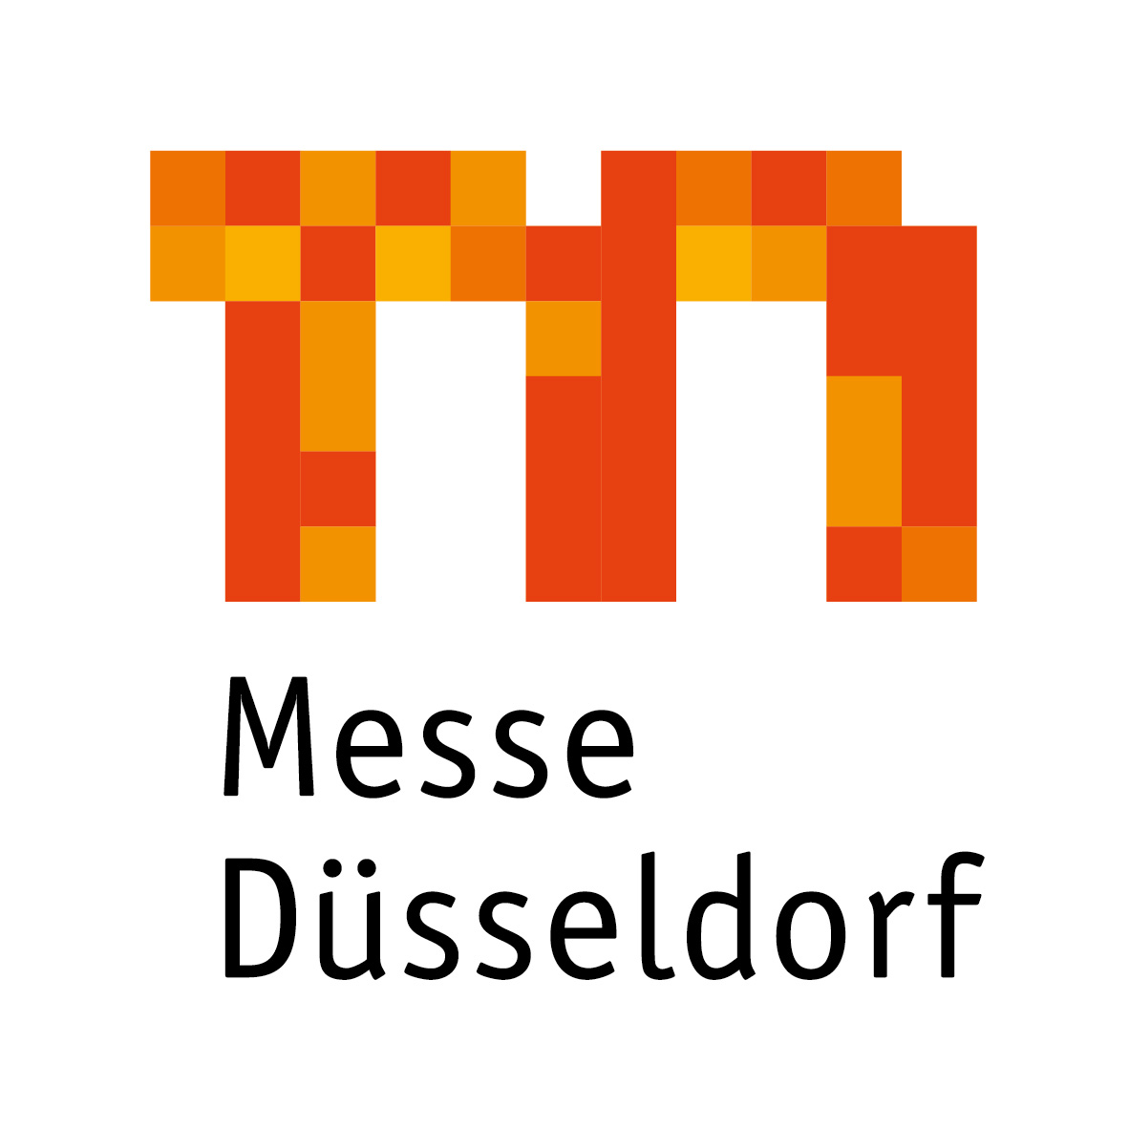

Werner M. Dornscheidt continues to head company

President & CEO will remain in office until 2020

Supervisory Board decides to extend contract

In its meeting of 15 May 2018 the supervisory board of Messe Düsseldorf GmbH headed by its chairman Lord Mayor Thomas Geisel, extended the contract of Werner M. Dornscheidt (64) as President & CEO until 30 June 2020. Commenting on this decision Dornscheidt delighted: “It means a lot to me that I will be able to work for this company until 2020.” Opening the Neue Messe Süd, Hall 1 in 2019 as one of the outstanding construction projects in the history of Messe Düsseldorf and being able to finish his active professional career with the world’s two leading trade fairs interpack and drupa was a milestone for him, he said.

Dornscheidt started his career in 1979 as a manager in the central division for foreign trade fairs of then Düsseldorfer Messegesellschaft mbH – NOWEA. After briefly working for the subsidiary Internationale Messe Marketing GmbH he was in charge of the new projects in third countries at NOWEA International GmbH between 1984 and 1986. From 1986 to 1990 Dornscheidt headed the department for trade fairs and sales promotion events for Centrale Marketing-Gesellschaft der deutschen Agrarwirtschaft (CMA), before he assumed responsibility for all the company’s events abroad as Deputy Managing Director of Messe Düsseldorf International GmbH in 1990. During this period in 1996/1997 he temporarily managed the business of Messe Düsseldorf North America and served as a board member for Messe BVV AG, Brno, Czech Republic in 1998/1999. 1999 saw Dornscheidt join Messe Leipzig GmbH as chairman of the management board. As a President & CEO of Messe Düsseldorf GmbH he returned to his hometown on 1 January 2004.

Since 2007 Werner M. Dornscheidt has served as an honorary consul to the United States of Mexico in North Rhine-Westphalia. At yesterday’s supervisory board meeting he was given permission to continue in this office for, and in the interest of, the trade fair company beyond 2020.
According to Lord Mayor Geisel, the contract extension also marked continuity of leadership in an important transition phase of the company: “On Mr Dornscheidt’s watch, the central course for the future of the municipal subsidiary has been charted, especially in the areas of globalisation, digitalisation and optimisation of premises and services. This successful strategy is also expected to continue beyond 2020 – this is what we stand for as a supervisory body.” Geisel emphasised that the trade fair company operated without any subsidies and was one of the most profitable companies of this kind with its own premises in Europe.

2.689 characters (with spaces)

The Messe Düsseldorf Group*:
With a turnover of around EUR 360m in 2017, the Messe Düsseldorf Group maintained its position as one of Germany's most successful trade fair companies. To the tune of 28,700 exhibitors presented their products to 1.35m trade visitors at events in Düsseldorf this year. They were joined by over half a million visitors to various conventions. About 50 trade fairs were held in Düsseldorf, including 23 No. 1 events in five areas of expertise: machinery, plants and equipment, retail, skilled crafts and services, medicine and healthcare, fashion and lifestyle, and also leisure. In addition, there were about 70 proprietary, joint and contracted events outside Germany, demonstrating that the Messe Düsseldorf Group is a leading global platform for export. Messe Düsseldorf GmbH is the trade fair company with the highest degree of internationalism in capital goods exhibitions. In 2017 Messe Düsseldorf's proprietary events in machinery, plants and equipment attracted approx. 74% international exhibitors and 73% trade visitors from other countries to the Rhine. In all, Düsseldorf trade fairs were attended by customers from about 180 countries. The Group runs a global network of sales offices in 139 countries (75 international representations) as well as centres of expertise in 8 countries.
* All figures subject to final balance sheet

Contact: Düsseldorf, 15 May 2018
Corporate Communications
Dr. Andrea Gränzdörffer
Tel.: +49(0)211/4560-555
Fax: +49(0)211/4560-8548
Email: graenzdoerffera@messe-duesseldorf.de

